Test Documentation

Manual Testing
User Story 13 | As an API Consumer, I want the server to throw an error if a page doesn’t exist, so that I know which pages exist.
Test Case ID | 1
Description | Using an invalid URL
Given | - The Application Server and Database Server is running  - Postman REST Client Opened
When | - Set GET request  - Enter URL http://localhost/Cosmere/public/information  - Press send
Then | - HTTP Response 404 Not Found
Test Status | Passed

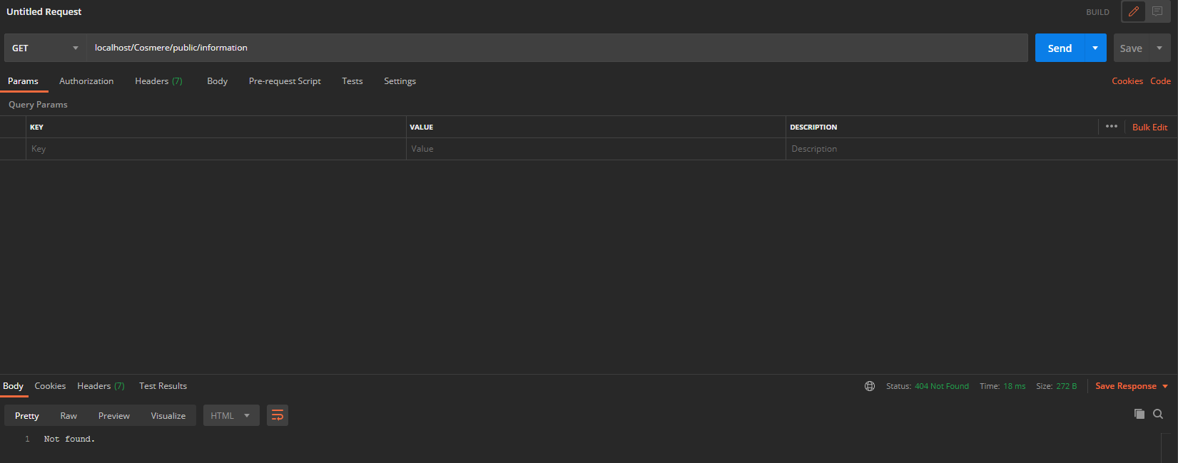

User Story | General – Applies to all
Test Case ID | 2
Description | Database server is unavailable
Given | - The Application Server is running  - The Database Server is stopped  - Postman REST Client Opened
When | - Set GET request  - Enter URL http://localhost/Cosmere/public/  - Press send
Then | - HTTP Response 500 Internal Server Error
Test Status | Passed

User Story 1 | As an API Consumer, I want to retrieve data in JSON format for all books, so that I can use the data in my client application.
Test Case ID | 3
Description | Retrieve data for all books - Success
Given | - The Application Server and Database Server is running  - Postman REST Client Opened
When | - Set GET request  - Enter URL http://localhost/Cosmere/public/books  - Press send
Then | - HTTP Response 200 OK  - All database entries are displayed in JSON format
Test Status | Passed

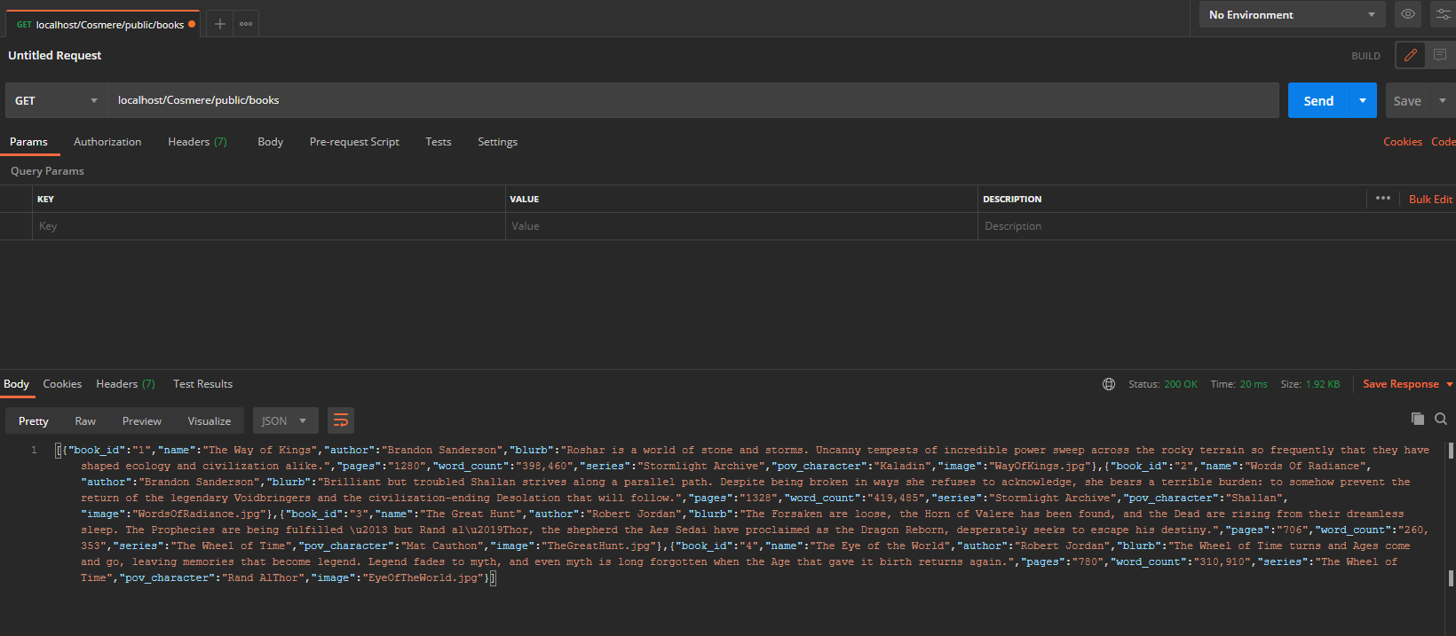

User Story 2 | As an API Consumer, I want to retrieve data in JSON format for one book based on its ID, so that I can use the data in my client application.
Test Case ID | 4
Description | Retrieve data based on ID - Success
Given | - The Application Server and Database Server is running  - Postman REST Client Opened
When | - Set GET request  - Enter URL http://localhost/Cosmere/public/book/1  - Press send
Then | - HTTP Response 200 OK  - Details for book displayed corresponding to entered ID
Test Status | Passed

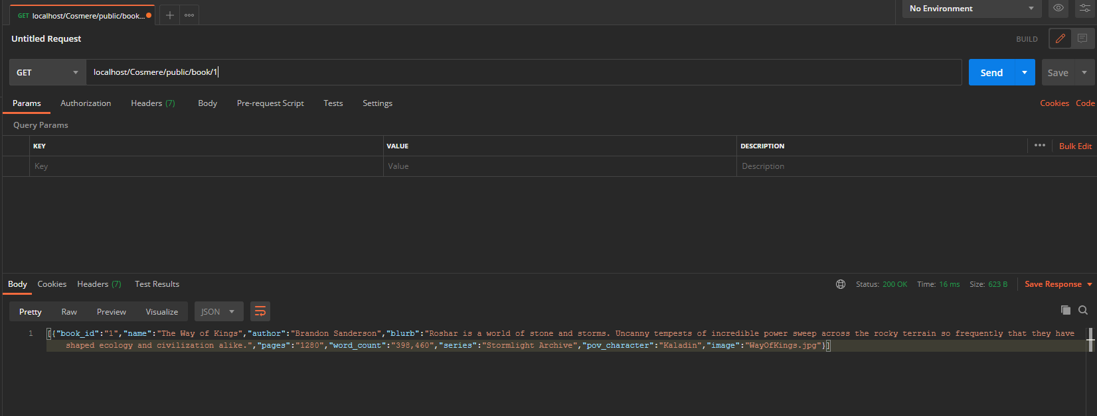

User Story 4 | As an API Consumer, I want to delete a book for a specified id, so that I can use the data in my client application.
Test Case ID | 6
Description | Delete data based on id - Success
Given | - The Application Server and Database Server is running  - Postman REST Client Opened
When | - Set DELETE request  - Enter URL  http://localhost/Cosmere/public/books/1  - Press send
Then | - HTTP Response 200  - Successfully deleted
Test Status | Passed

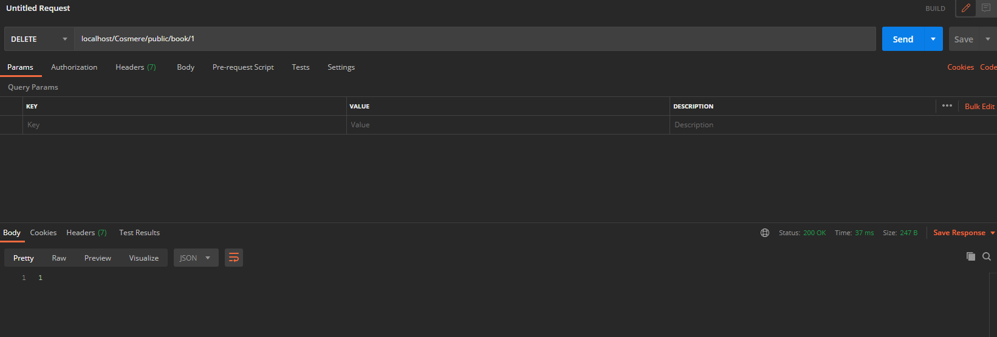

User Story 4 | As an API Consumer, I want to delete a book for a specified id, so that I can use the data in my client application.
Test Case ID | 5
Description | Delete data based on incorrect - Success
Given | - The Application Server and Database Server is running  - Postman REST Client Opened
When | - Set DELETE request  - Enter URL  http://localhost/Cosmere/public/books/1  - Press send
Then | - HTTP Response 200  - JSON dataset of 0
Test Status | Passed

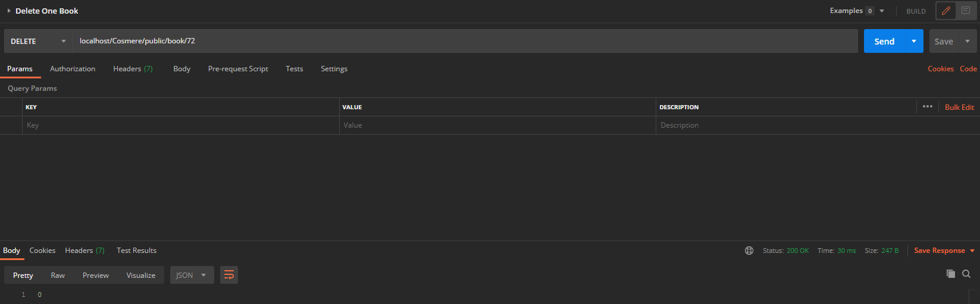

User Story 5 | As an API Consumer, I want to retrieve a list of books in JSON format for a specified name, so that I can use the data in my client application.
Test Case ID | 7
Description | Incorrect id is entered when retrieving a book - Success
Given | - The Application Server and Database Server is running  - Postman REST Client Opened
When | - Set GET request  - Enter URL  http://localhost/Cosmere/public/books/72  - Press send
Then | - HTTP Response 200  - Empty JSON data
Test Status | Passed

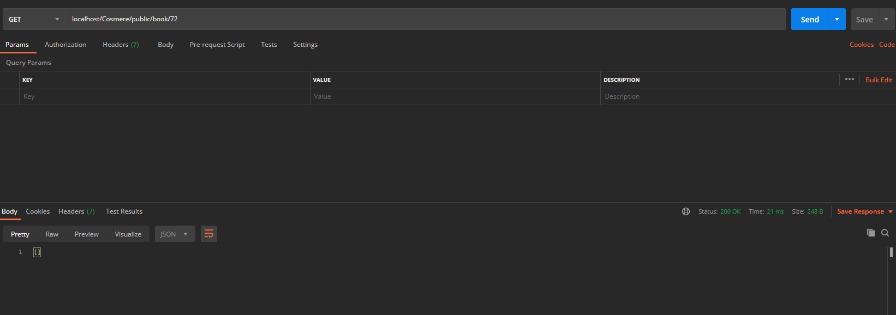

User Story 6 | As an API Consumer, I want to update a book for a specified id, so that I can use the data in my client application.
Test Case ID | 8
Description | Update data based on id - Success
Given | - The Application Server and Database Server is running  - Postman REST Client Opened
When | - Set PUT request  - Enter URL  http://localhost/Cosmere/public/books/1  - Fill in x-www-form-urlencoded field in POSTMAN  - Press send
Then | - HTTP Response 200  - Successfully updated
Test Status | Passed

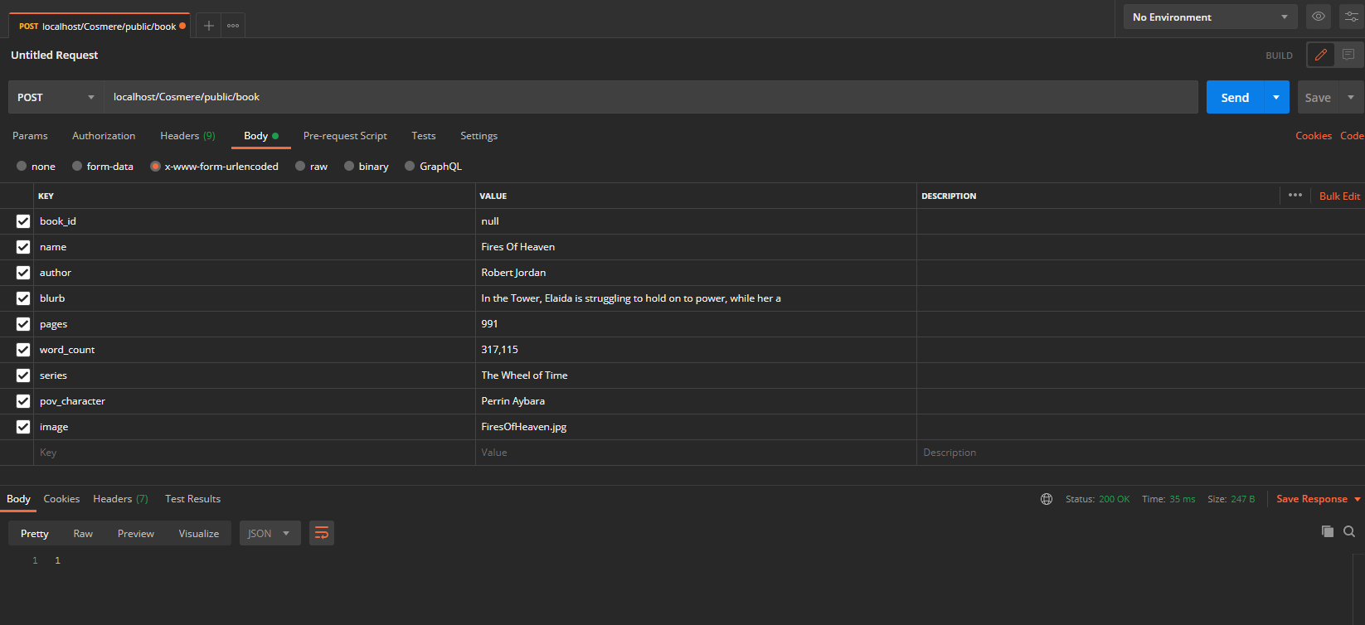

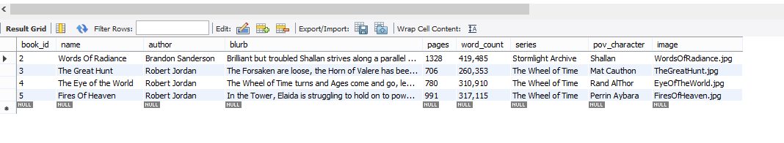

User Story 7 | As an API Consumer, I want to add in new a book, so that I can use the data in my client application.
Test Case ID | 9
Description | Add in a new book - Success
Given | - The Application Server and Database Server is running  - Postman REST Client Opened
When | - Set POST request  - Enter URL  http://localhost/Cosmere/public/book  - Fill in x-www-form-urlencoded field in POSTMAN  - Press send
Then | - HTTP Response 200  - Successfully deleted
Test Status | Passed

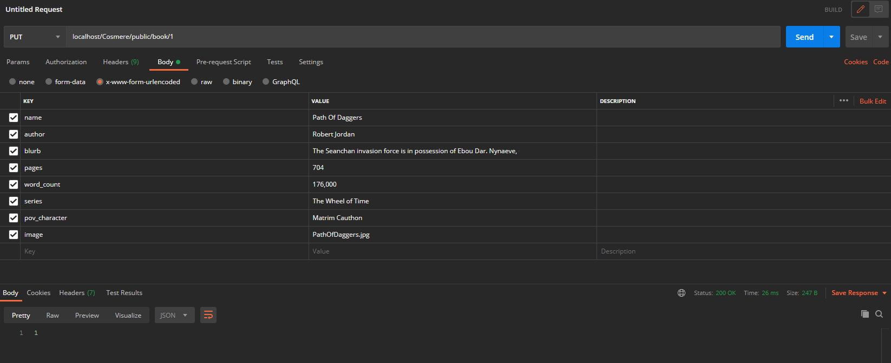

User Story 6 | As an API Consumer, I want to retrieve a list of books in JSON format for a specified name, so that I can use the data in my client application.
Test Case ID | 10
Description | Incorrect id is entered when retrieving a book - Success
Given | - The Application Server and Database Server is running  - Postman REST Client Opened
When | - Set GET request  - Enter URL  http://localhost/Cosmere/public/books/72  - Fill in x-www-form-urlencoded field in POSTMAN  - Press send
Then | - HTTP Response 200  - JSON dataset of 0
Test Status | Passed

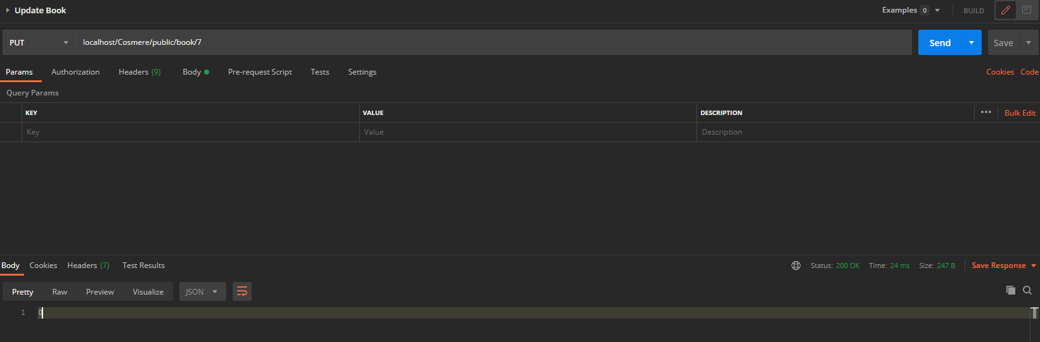

User Story 6 | As an API Consumer, I want to update a book for a specified id, so that I can use the data in my client application.
Test Case ID | 11
Description | Update data based on incorrect id - Success
Given | - The Application Server and Database Server is running  - Postman REST Client Opened
When | - Set PUT request  - Enter URL  http://localhost/Cosmere/public/books/72  - Fill in x-www-form-urlencoded field in POSTMAN  - Press send
Then | - HTTP Response 200  - JSON dataset of 0
Test Status | Passed

Test Report Summary

Test Type | Number Passed | Number Failed
Manual | 11 | 0

Bug Report
There are currently no known existing bugs in this project.

